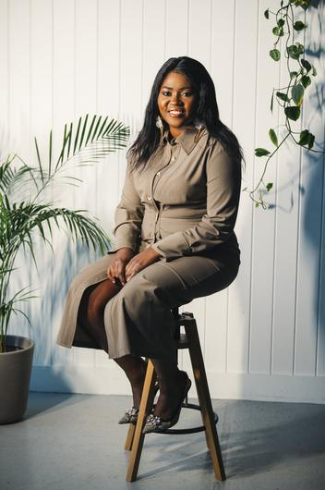
Ellie Kisyombe, founder of Our Table and social activist
What’s your story?
My name is Ellie Kisyombe and I was born and raised in Malawi and I moved over here to Ireland a few years ago. me!

Can you tell us more of the insights around why you set up OurTable?
Well it was a response to the ban on asylum seekers being able to cook their own cultural meal, and not only their own cultural meal, but not being given the chance to prepare their own meals. As you know like, we as mothers from the cultural backgrounds from which we’re coming, children learn more about familyhood by seeing their parents and mothers cooking for them and passing down this cultural culinary skill – and even knowing the food from where your parents are coming from is being able to understand yourself. So, food is political. There is more to food. You can’t have a healthy family without healthy food on the table. So, this was the start of Our Table. It was a response to that and not only that but when you’re in DP you live long periods in there where you’re unable to be active and not even able to go out. You know, mental health in these places are big problems. Some people have lived in DP for five and half years so you can imagine, you become unemployable and you get a low self-esteem. So, this is what we looked at when we started Our Table. So, when they come out, they can integrate in breaking bread and start a conversation. And also, asylum seekers are not allowed to work. When I started Our Table I was not taking a wage. The people working around me who had the right papers could get paid but I could not. We’re trying to expand now and looking at how we can get funding and how we can employ more people. There is a need to try and bring these different cultures in Ireland together and break those barriers.

