Online Workshop
2022 -2023

Table of Contents
I. Introduction 5
II. Methodology 6
Grassroots to Government Pilot (May 2022 – November 2022) 6
1. Course Development and Recruitment: 6
2. Evaluation Methods Used: 6
a. Interviews: 6
b. Specific Content Creation: 6
c. Four-Week Course: 7
3. Building Links and Relationships: 8
4. Participant Responses and Outcomes: 8
5. Creating a Network for Future Learning: 8
6. Recommendations for Project into 2023: 8
7. Conclusion: 8
Grassroots to Government Program 2023 9
1. Program Overview: 9
2. Online Workshops: 9
3. Engaging Informal and Interactive Sessions: 9
4. Convenient Online Format: 9
5. The Grassroots Government Final Event: 9
6. Speaker Panel and Topics: 9
7. Interactive Workshop with Siona Cahill: 10
8. Logistics and Comfort: 10
9. Exploring Key Topics: 10
10. Inspiring Action and Empowerment: 10
11. Four Week Course Themes 11
Sampling Techniques and Sample Size 11
Data Collection Procedures and Tools 12
1. Interviews: 12
2. Facilitated Online Workshop Sessions: 12
3. Case Studies: 12
Analysis methods employed 12
III. Program Overview 13
Goals: 13
Target Audience: 13
Duration: 13
Resources: 13
Stakeholders Involved: 13
- Participants: 14
- Project Team: 14
- Experts and Speakers: 14
- Northern Ireland Rural Women's Network (NIRWIN): 14
- Center for Cross Border Studies: 14
Partnerships: 14
- Northern Ireland Rural Women's Network (NIRWIN): 14
- Center for Cross Border Studies: 14
- Local Organizations and Groups: 14
IV. Evaluation Findings 15
A. Effectiveness of the Program in Achieving Its Objectives: 15
B. Impact of the Program on Participants' Political Knowledge, Attitudes, and Behaviours: 15
Key Accomplishments of the Program: 15
C. Identification of Strengths and Weaknesses of the Program: 16
Strengths: 16
Weaknesses: 16
D. Evaluation of Program Implementation: 16
Adherence to planned activities: 16
Utilization of resources: 16
End of the session event: 16
V. Recommendations 17
A. Based on the evaluation findings, proposed recommendations for program improvement: 17
1. Increase participant recruitment efforts: 17
2. Extend program duration: 17
3. Enhance resources and materials: 17
B. Strategies to address identified weaknesses and enhance program effectiveness: 17
1. Implement targeted marketing and communication strategies: 17
2. Conduct participant feedback sessions: 17
3. Offer ongoing support and mentorship: 17
4. Expand collaborations with local decision-making structures: 17
C. Suggestions for further research or areas of exploration related to political awareness: 17
1. Long-term impact assessment: 17
2. Intersectionality and inclusivity: 18
3. Comparative analysis: 18
4. Collaborative research: 18
VI. Conclusion 18
A. Summary of the Evaluation Findings and Their Implications: 18
B. Reiteration of Key Recommendations for the Program: 18
VII. Appendices 19
A. Questionnaire for video interviews 19
B. Infographics and Promotional material 20
1.Poster for Facebook page for recruitment 20
2. Grassroots to Government logo 21
3. Examples of short infographics used in the program 22
4. Program Promotion Flyer Design 23
D. Links to important information 23

I. Introduction
The Grassroots to Government pilot program was an empowering and educational initiative designed to enhance the participation of women in local decision-making processes and structures in rural Ireland. Its primary objective was to equip and educate a cohort of women about the value of their involvement in community networks and organizations, fostering their understanding of the role they play and the impact they can make. The program aimed to inspire women to develop relevant knowledge and engage in local politics, fostering future learning and cooperation.
One of the key goals of the program was to encourage women's participation in local democracy projects on both sides of the borders, fostering advocacy and promoting mutual understanding of the challenges faced by women in different jurisdictions. Through this program, valuable connections were established with women's groups and organizations, facilitating communication and collaboration.
Due to the unforeseen challenges posed by the COVID-19 pandemic, the program had to adapt to ensure continuous engagement with participants. It served as an anchor for maintaining contact with women and provided essential links to other women's groups and organizations in the community, fostering support and promoting the program's future endeavours.
Throughout 2022, the program focused on developing a comprehensive short course tailored to the needs of two distinct groups: one based in the Republic of Ireland and the other in Northern Ireland. The course content was thoughtfully designed to provide women with the necessary knowledge and skills to actively engage in community initiatives and campaigns. The program successfully established key connections with individual women, groups, and organizations, creating a robust network of support and collaboration.
The course content encompassed various aspects, including information on the policymaking processes in both jurisdictions, emphasizing the significance of gender within policy formulation. It featured case studies from Ireland and beyond, showcasing the transformative power of women's participation in driving positive change. To enhance the learning experience, short infographics were created and made accessible on the Grassroots to Government website, complementing the course materials.
The culmination of the program was a four-week course, conducted between September and October 2022, which was tailored to the specific interests and geographical context of each group. These sessions, lasting two hours each, attracted a diverse group of 18 women, representing different backgrounds and age groups.
In 2023, the program continued its efforts with four facilitated online sessions between May and June, involving a group of women from both Northern Ireland and the Republic of Ireland in collaboration with NIRWIN (Northern Ireland Rural Women's Network). These sessions invited experts from community organizations to educate and facilitate discussions on various aspects of community services, local government electoral systems, and the political landscape. The sessions were attended by 17 women, reflecting a mix of backgrounds and ages, with some already engaged in campaigns and projects, while others were eager to explore greater involvement.
The program's grand finale took place on Friday, May 26, 2023, with an exceptional panel of distinguished speakers, accompanied by an interactive workshop led by Siona Cahill. The speakers covered a wide range of topics, with a particular focus on the pivotal role of women in society, especially in rural regions of Ireland. They highlighted the challenges faced by women due to differences in cross-border local community infrastructure, social services, employment, education, transport, childcare, and local laws. Strategies and approaches to address these challenges were also discussed.
Overall, the Grassroots to Government pilot program successfully equipped women with the necessary knowledge, skills, and confidence to actively participate in decision-making processes within their communities. By incorporating engaging content, personal testimonies, and practical insights, the program empowered women, amplifying their voices for meaningful change and fostering lasting connections within the community.
By incorporating more specific details about the program's activities, outcomes, and impact, the revised introduction provides a clearer and more comprehensive overview of the Grassroots to Government pilot program.

II. Methodology

Grassroots to Government Pilot (May 2022 – November 2022)

1. Course Development and Recruitment:
One of the key objectives of this program was the development of content and resources in participant-friendly educational material. Therefore, the pilot focused on the development of a short course that introduced a cohort of women to the value of women’s participation within local decision-making processes and structures.
Over a span of six months, the program focused on developing a short course tailored to the needs of two groups: one based in the Republic of Ireland and one in Northern Ireland. The program established important links with individual women, groups, and organizations to ensure wide participation and support.

2. Evaluation Methods Used:

a. Interviews:
Short video interviews were conducted with five women involved in various campaigns and projects. The interviews aimed to gather insights into their experiences, challenges, successes, and the importance of women's voices in these endeavors. The interviews were shared on the Grassroots to Government YouTube channel, providing valuable insights into the role of women in campaigns. (Appendix: Interview Questionnaire)

b. Specific Content Creation:
Content was developed for each group, covering key aspects of the program, such as policymaking processes, the value of gender in policy formulation, and case studies from Ireland and beyond. Short infographics were also created to supplement the course materials and were used during the sessions. These infographics were made accessible on the Grassroots to Government website. (Appendix: Examples of Infographics)

c. Four-Week Course:
- A customized four-week course was delivered between September and October 2022, with sessions lasting two hours each.
- The course topics were tailored to the interests and geographical context of each group, ensuring relevance and engagement.
- A total of 18 women attended the sessions, representing diverse backgrounds and age groups.

Agenda & Themes
A typical agenda for a session involved identification of our role in social policy based on the discussion and why gender matters in social policy. It also focussed on methods to gender proof the process of social policy making.
Table-1:The sessions focused on civic participation, local democratic structures, building confidence, and advocating for others.
Session | Topic | Learning Outcome | Key Questions
1 | Introductory Political Education Module - Civic Participation | 1. Enable participants to describe some of their own activities as important elements to civic society  2. Enable participants to be able to describe civic society and participation. | What do we mean by participation and civic society?  What have they got to do with women and equality and politics?  Is what I do, grassroots participation? And why it's important.
2 | Local Democratic Structures | Understand the value of civic participation to areas such as health, housing, employment and education.  Understand how decisions are made in our local political structures – councils, PPNs, community planning NI and Government Departments.  Discuss power and the value of participation to balance power and decision making in civil society. | What is democracy and how does in work across our communities and into the political sphere?
3 | Building Confidence: Amplifying your voice | Understanding our role within local decision making – through groups and campaigns  How to engage with local structures eg PPN and Community Planning NI. | How to ensure our voices are heard?  How to connect with local structures and local decision makers.
4 | Building Confidence: Advocating for Others | Understand the value of voting  Seeing the importance of elections and how this helps ensure change. | How do the voting systems work and what differences are there in local and national systems of government?  How can voting make a difference to our lives and the lives of others?

3. Building Links and Relationships:
The program established links with various organizations and groups, such as North Leitrim Women's Centre, Hilltown Women's Group, PPN in Leitrim, and Community Planning in Newry, Mourne, and Down District. The project officer also formed a steering group comprising women involved in campaigns from Donegal, Leitrim, and Monaghan, who assisted with course content development and participant recruitment. The program's Facebook page and website played a crucial role in sharing project aims and connecting with rural women's groups and organizations.

4. Participant Responses and Outcomes:
Although the number of participants was smaller than anticipated (18 in total), the level of participation within the groups was high, indicating strong engagement and interest. Participants expressed a desire to continue working together and participate in future opportunities. The participants realized that social policy covers all aspects of their lives, including employment, education, community, and health services, and that women have an important insight as an essential part of the social fabric. They recognized the need to educate themselves, take actions to ensure that the right policies are in place, and participate in the policy-making processes in their capacity. The program facilitated the development of confidence, understanding of local decision-making processes, and advocacy skills among the participants. Each session included journal activities to encourage reflection and enhance learning.

5. Creating a Network for Future Learning:
Both groups expressed a desire to continue their collaboration and participation in future initiatives. Participants formed connections with local decision-making structures and engaged with PPN and Community Planning NI. The program's materials, including videos, Facebook page, website, and infographics, can be utilized by other groups and organizations, contributing to the development of a wider network.

6. Recommendations for Project into 2023:
1) Increase the project officer's hours to allow for wider recruitment and further development of content and resources.
2) Produce professionally branded participant-friendly educational materials to enhance the program's presence and impact.
3) Promote the project through partnerships with PPNs, Community Planning NI, and women's networks.

7. Conclusion:
The Grassroots to Government pilot program's first year showed promising outcomes, with active participation, positive feedback, and a desire for continued engagement among the participants. The evaluation methods employed, including interviews, specific content creation, and the four-week course, effectively captured the program's impact and effectiveness. Building links and relationships with organizations and groups strengthened the program's reach and potential for future collaboration.
Importance of face-to-face group learning and the value of creating a network for future learning and support were highlighted. The recommendations provided for the project's suggested continuation in 2023 focus on expanding recruitment efforts, improving resources, and leveraging partnerships with PPNs, Community Planning NI, and women's networks. By implementing these recommendations, the Grassroots to Government program could build upon its initial success in empowering women in local decision-making processes.

Grassroots to Government Program 2023
In continuation of the goals and objectives set forth by the previous year's program, this program was designed to take the awareness of grassroots level participation one step further towards a broader audience. The program consisted of four facilitated online sessions followed by a face-to-face interactive workshop known as The Grassroots Government Final Event, based on the recommendation of the previous year's program.

1. Program Overview:
The program consisted of a series of online workshops held on Tuesday 2nd, 9th, 16th, and 23rd May 2023 from 10.30 am to 12 pm and an interactive session on 26th May 2023.

2. Online Workshops:
These workshops provided participants with the opportunity to engage in informal and engaging conversations with women at the grassroots level, focusing on advocacy work, community involvement, and related topics. A group of 17 women from both Northern Ireland and Republic of Ireland was created to attend these sessions.

3. Engaging Informal and Interactive Sessions:
The workshops created an inclusive and interactive environment where participants freely exchanged ideas, asked questions, and learned from the experiences of guest speakers. The sessions featured accomplished women who shared their insights, practical advice, and personal stories, inspiring participants to actively contribute to advocacy work and community engagement.

4. Convenient Online Format:
The online format of the workshops allowed participants to join from their preferred locations, offering convenience and accessibility. The virtual setting facilitated meaningful conversations and encouraged active participation from attendees.

5. The Grassroots Government Final Event:
Building upon the knowledge and insights gained from the online workshops, The Grassroots Government Final Event was held on Friday 26th of May. The event took place at the Ulster Canal Stores, starting at 10 am and concluding with a hot lunch at 1 pm before departure at 2 pm. This face-to-face workshop provided participants with an opportunity to interact directly with distinguished speakers and engage in an immersive learning experience.
The "Grassroots to Government" event was held on May 26th at the Ulster Canal Stores, aiming to foster dialogue between community members and government representatives. The day began with a warm welcome, offering tea and scones to the attendees upon their arrival. Karen Reilly from Longford Women Link introduced the event, inviting Tara Farrell, the CEO of Longford Women's Inc., to open the event and set the tone for the day. She acknowledged the presence of Anne Marie, Sadia, and Siona Cahill as the esteemed speakers and emphasized the context of the day.

6. Speaker Panel and Topics:
The event featured an outstanding panel of speakers who covered diverse topics centred around the pivotal role of women in society, with a particular emphasis on rural regions of Ireland. Karen Reilly introduced the agenda of the event These speakers delved into identification of issues in the lives of rural women, the need for advocacy as well as strategies and approaches to effectively harness women's voices for the purpose of instigating transformative change. The subjects explored during the event encompassed various aspects of women's empowerment and community engagementn and emphasized to foster dialogue between community members and government representatives.
The event began with a warm welcome from Karen Reilly, a program mentor from Longford Women Link, followed by Tara Farrell, the CEO of Longford Women's Inc., who opened the event and expressed gratitude for the participants' attendance. The event marked the culmination of the collaborative "Grassroots to Government" program between Longford Women's Link and the Northern Ireland Rural Women's Network, funded by the Department of Foreign Affairs.
Three speakers shared their insights during the event. Sadia Athar discussed her journey with Longford Women Link and her increased interest and empowerment in advocating for women's issues and participating in policy-making as a migrant woman and a naturalized citizen living in rural Ireland. Annemarie O Kane from the Center for Cross-Border Studies highlighted the challenges faced by people, particularly women, living in the border area between Northern Ireland and the Republic of Ireland, focusing on issues arising from Brexit and the Pandemic.
During the "Grassroots to Government" event, Siona Cahill provided valuable insights into her role in politics and her experiences as a campaigner and advocate. She shared her involvement in the marriage equality campaign, highlighting the challenges faced by rural activists due to limited resources. Siona emphasized the phenomenal power of women, highlighting their ability to emerge from the struggles of domestic violence and childcare. She stressed the importance of women taking proactive roles and raising their voices across all platforms to effectively influence decision-making processes. Siona emphasized the need for women to speak up and advocate for policy changes, pushbacks, or adjustments that would facilitate their empowerment and better serve their needs. Her perspective underscored the significance of women's active participation and engagement in shaping policies that directly impact their lives.

7. Interactive Workshop with Siona Cahill:
An interactive workshop led by the experienced facilitator, Siona Cahill, was a key highlight of the event. This workshop aimed to provide participants with a comprehensive and engaging session, enhancing their understanding and knowledge of the overall program. Through interactive activities and group discussions, participants had the opportunity to explore practical strategies and methods for driving positive change within their communities.

8. Logistics and Comfort:
To ensure the comfort and well-being of attendees, transportation facilities and refreshments were provided. The organizers kindly requested participants to communicate any specific dietary requirements in advance, enabling them to make the necessary arrangements.

9. Exploring Key Topics:
Throughout the program, participants had the opportunity to explore various aspects of advocacy, including strategies, community involvement, and the importance of civic participation and equality. The workshops aimed to motivate and empower individuals by showcasing the experiences of successful women who have made a significant impact in their communities.

10. Inspiring Action and Empowerment:
By learning from the real-life experiences of women at the grassroots level, participants gained valuable insights, built networks, and were inspired to take action in their own communities. The workshops played a crucial role in encouraging participants to make a positive difference through advocacy and community work.

11. Four Week Course Themes
Table- 2 The sessions focused on civic participation, local democratic structures, building confidence, and advocating for others.
Week | Topic | Learning Outcome | Key Questions
1 | Introductory Political Education Module - Civic Participation | Enable participants to describe some of their own activities as important elements to civic society  Enable participants to be able to describe civic society and participation. | What do we mean by participation and civic society?  What have they got to do with women and equality and politics?  Is what I do, grassroots participation? And why it's important.
2 | Local Democratic Structures | Understand the value of civic participation to areas such as health, housing, employment and education.  Understand how decisions are made in our local political structures – councils, PPNs, community planning NI and Government Departments.  Discuss power and the value of participation to balance power and decision making in civil society. | What is democracy and how does in work across our communities and into the political sphere?  What is the status of Gender imbalance in local politics and what can we do to offset its effect
3 | Building Confidence: Amplifying your voice | Understanding our role within local decision making – through groups and campaigns  How to engage with local structures e.g. PPN and Community Planning NI. | How to ensure our voices are heard?  How to connect with local structures and local decision makers.  How community safety partnership organizations ensure our safety and address our concerns
4 | Building Confidence: Advocating for Others | Understand the value of voting, importance of elections, Political Journey of local community leader  Structure and organization community events and participation  Seeing how this helps ensure change. | How to take part in electoral process and how to stand in election.  How can voting make a difference to our lives and the lives of others?

Sampling Techniques and Sample Size
The program attracted a diverse group of 18 women representing various backgrounds and age groups for the four-week course conducted between September and October 2022. Additionally, 17 women attended the facilitated online sessions conducted between May and June 2023. The sample size is relatively small but appears to be suitable for a pilot program aimed at testing the feasibility and effectiveness of the interventions.

Data Collection Procedures and Tools
It's important to note that the interviews, focus group discussions, and case studies are commonly used qualitative data collection techniques that can provide valuable insights and perspectives from participants.
1. Interviews:
Short videoed interviews were conducted with five women involved in various campaigns and projects. These interviews aimed to gather insights into their experiences, challenges, successes, and the importance of women's voices in their endeavours. The interviews likely involved open-ended questions to elicit detailed responses from the participants.

2. Facilitated Online Workshop Sessions: Facilitated online workshop sessions were conducted involving a group of women from both Northern Ireland and the Republic of Ireland. These sessions were designed to provide interactive learning and collaboration opportunities for the participants. Benefits of facilitated online workshop sessions include:

a. Increased Accessibility: By conducting the workshops online, participants from different locations can easily join without the need for travel, making it more accessible and inclusive.

b. Facilitated online sessions: These online workshops were conducted involving a group of women from both Northern Ireland and the Republic of Ireland. These sessions involved group discussions facilitated by experts from different community organizations. The discussions would have focused on topics related to community services, local government electoral and political systems, and other relevant subjects.

3. Case Studies:
The program developed specific content for each group, including case studies from Ireland and beyond. These case studies likely provided real-life examples and stories that illustrate the significance of women's participation in driving positive change. The case studies would have been used as educational materials during the course sessions.

Analysis methods employed
The interviews provided valuable insights into the role of women in campaigns, indicating that the analysis involved qualitative analysis of the interview responses. The program aimed to assess participant responses and outcomes, including their level of engagement, interest, and desired future collaboration.
Overall, the program employed a combination of qualitative methods, including interviews, observations and feedback questions from the participants. Interview responses and participant feedback to assess the program's effectiveness in empowering and educating women for active participation in decision-making processes.

III. Program Overview

Goals:
The Grassroots to Government pilot program aimed to empower and educate a cohort of women in rural Ireland about the value of their participation in local decision-making processes and structures. It sought to equip women with the necessary knowledge, skills, and confidence to actively engage in community initiatives and campaigns. The program aimed to amplify women's voices and promote meaningful change by emphasizing the importance of gender in policy formulation.

Target Audience:
The target audience of the program was women in rural Ireland. The program was designed to cater to two distinct groups: one based in the Republic of Ireland and the other in Northern Ireland. The participants represented diverse backgrounds and age groups.

Duration:
The program spanned over a period of time, with different phases and activities taking place during specific timeframes. The key timeframes were as follows:
- Course Development and Recruitment: Six months from May 2022 to November 2022.
- Four-Week Course: Conducted between September and October 2022, with sessions lasting two hours each.
- Facilitated Online Sessions: Four sessions conducted between May and June 2023.
- Final Event: Organized on Friday, 26th May 2023.

Resources:
During the implementation of the Grassroots to Government pilot program, various resources were utilized to support its activities and objectives. These resources include:
1. Course Development: Resources were allocated to develop participant-friendly educational materials, including the creation of tailored course content, case studies, short infographics, a YouTube channel, and a website.
2. Video Interviews: Resources were dedicated to conducting short video interviews with women involved in campaigns and projects, capturing their experiences and insights.
3. Facilitated Sessions and Workshops: The program allocated resources to conduct four-week courses and facilitated online sessions, ensuring the availability of knowledgeable facilitators, materials, and technology required for effective delivery.
4. Networking and Collaboration: Resources were invested in establishing links with individual women, groups, and organizations. This involved time and effort to connect with stakeholders and foster relationships for future collaboration and support.

Stakeholders Involved:
The successful implementation of the Grassroots to Government pilot program required the involvement of various stakeholders. These stakeholders played critical roles in supporting and contributing to the program:
- Participants: Women from rural Ireland, representing diverse backgrounds and age groups, actively engaged in the program's activities, including the four-week course, facilitated sessions, and the final event.
- Project Team: The project team, responsible for the design, development, and implementation of the program, coordinated various activities, including course development, recruitment, and engagement with participants.
- Experts and Speakers: Experts from different community organizations were invited to facilitate discussions and provide insights on various aspects of community services, local government, electoral and political systems. Distinguished speakers, including Siona Cahill, led workshops and shared their expertise on the role of women in society and addressing challenges in rural regions.
- Northern Ireland Rural Women's Network (NIRWIN): NIRWIN, a key partner in the program, collaborated in the facilitation of online sessions. They contributed expertise, resources, and connections to ensure the program's success.
- Center for Cross Border Studies: Center for Cross Border Studies, another partner in the program, likely played a role in supporting the program's implementation, possibly through providing resources, connections, or expertise related to cross-border issues and challenges faced by frequent visitors.

Partnerships:
The Grassroots to Government pilot program leveraged partnerships with various organizations and groups to enhance its reach, resources, and impact:
- Northern Ireland Rural Women's Network (NIRWIN): NIRWIN collaborated in the implementation of the program, specifically in conducting facilitated online sessions. Their involvement ensured the program's accessibility and relevance to women in both Northern Ireland and the Republic of Ireland.
- Center for Cross Border Studies: Center for Cross Border Studies likely contributed to the program through their partnership, possibly by providing support and insights on cross-border challenges and issues related to community infrastructure, social services, and local laws.
- Local Organizations and Groups: The program established stronger connections and partnerships with various organizations and groups, such as North Leitrim Women's Centre, Hilltown Women's Group, PPN in Leitrim, and Community Planning in Newry, Mourne, and Down District. These partnerships provided additional support, resources, and connections for participant recruitment and collaboration.
The program's partnerships with NIRWIN, Center for Cross Border Studies, and other local organizations were crucial in expanding its network, fostering collaboration, and ensuring the program's relevance to the target audience.

IV. Evaluation Findings

A. Effectiveness of the Program in Achieving Its Objectives:
Qualitative data from interviews and workshop group discussions demonstrated that the Grassroots to Government program was effective in achieving its objectives. The findings include:
Participants expressed increased awareness of the value of women's participation in local decision-making processes and structures. Many participants showed interest in registering for the local electoral process and were enthusiastic about actively participating in local political activities. Some participants also expressed interest in advocacy and even standing in local elections.
The program successfully provided participants with the necessary knowledge and skills to actively engage in community initiatives and campaigns. Participants felt motivated to increase their involvement in community activities and showed keen interest in understanding more about local government and non-government bodies involved in policy-making.
Participants reported feeling empowered and confident in their ability to contribute to local decision-making. They felt equipped with the knowledge required for advocacy and involvement with local politics.

B. Impact of the Program on Participants' Political Knowledge, Attitudes, and Behaviours:
The Grassroots to Government program had a significant impact on participants' political knowledge, attitudes, and behaviours. Key findings include:
- Participants exhibited increased understanding of how policy is made in both jurisdictions, recognizing the value of gender in policy formulation and highlighting the importance of women's voices in driving positive change.
- Participants showed an increased willingness to engage with local democratic structures, such as councils, Public Participation Networks (PPNs), and community planning initiatives.
- The program fostered a sense of agency and motivation among participants, leading to their active involvement in campaigns, projects, and other community activities.
- The program expanded participants' political knowledge, nurtured positive attitudes, and empowered them to contribute effectively to their communities.

Key Accomplishments of the Program:
1. Increased knowledge about political systems, policies, and rights among participants.
2. Engaged and educated a diverse range of target audiences, including students, young adults, marginalized communities, and the general public.
3. Addressed specific knowledge gaps identified through a comprehensive needs assessment.
4. Developed and delivered engaging and informative content on political topics through various mediums such as videos, infographics, presentations, and interactive activities.
5. Fostered critical thinking skills among participants, encouraging them to analyze and evaluate different perspectives on political issues.
6. Provided opportunities for participants to engage with elected officials, community leaders, and experts through panel discussions, guest lectures, and Q&A sessions.
7. Empowered participants to take action and engage in civic activities by providing information on voter registration, contacting elected representatives, and getting involved in community initiatives or advocacy groups.
8. Evaluated the program's effectiveness through feedback from participants, measuring knowledge gain, attitude changes, and behaviour modifications.
9. Fostered collaborations with community organizations, educational institutions, government agencies, and NGOs to expand the program's reach and impact.

C. Identification of Strengths and Weaknesses of the Program:

Strengths:
- Tailored content and resources: The program successfully developed and delivered course materials and resources tailored to the specific needs and interests of the participants.
- Building connections and networks: The program established valuable links with individual women, groups, and organizations, fostering collaboration and support.
- Practical application and engagement: The four-week course provided participants with practical opportunities to apply their knowledge and actively engage in community initiatives.

Weaknesses:
- Limited participant numbers: Although participant engagement was high, the overall number of participants was smaller than anticipated. Strategies to increase recruitment should be considered for future iterations.
- Need for extended duration: Some participants expressed a desire for a longer program duration to allow for deeper learning and continued skill development.

D. Evaluation of Program Implementation:
Adherence to planned activities: The program adhered to the planned activities, including the development of course content, recruitment of participants, and delivery of sessions.
Utilization of resources: The program effectively utilized resources, such as interviews, infographics, and online platforms (Facebook page, YouTube channel), to deliver content and engage participants.
End of the session event: The final event fostered interactive learning, networking, and inspiration, leaving a lasting impact on participants' motivation and commitment to driving positive change in their communities.
Overall, the evaluation findings indicate that the Grassroots to Government program was effective in achieving its objectives. It positively impacted participants' political knowledge, attitudes, and behaviours, empowering them to actively engage in local decision-making processes. The program demonstrated strengths in tailored content, building connections, and facilitating practical application while also identifying the need for increased participant recruitment and potential program duration extension. The evaluation confirms that the program was implemented as planned, utilizing available resources effectively.

V. Recommendations

A. Based on the evaluation findings, proposed recommendations for program improvement:
1. Increase participant recruitment efforts: Develop a comprehensive recruitment strategy to attract a larger number of participants for future iterations of the program. This could include targeted outreach through women's networks, community organizations, and partnerships with relevant institutions.
2. Extend program duration: Consider extending the program duration to allow for more in-depth learning, skill development, and engagement with participants. This could be achieved by incorporating additional sessions or expanding the course over a longer period.
3. Enhance resources and materials: Invest in developing professionally branded, participant-friendly education materials, including handouts, visual aids, and online resources. This will enhance the program's impact and promote a consistent and engaging learning experience.
4. Strengthen partnerships and collaborations: Forge stronger partnerships with PPNs, community planning NI, and women's networks to leverage their expertise, expand the program's reach, and ensure long-term sustainability. Collaborate with these organizations in designing and delivering program activities.

B. Strategies to address identified weaknesses and enhance program effectiveness:
1. Implement targeted marketing and communication strategies: Develop a comprehensive marketing and communication plan to raise awareness of the program, targeting both rural and urban areas. Utilize various channels, such as social media, local newspapers, and community events, to reach potential participants.
2. Conduct participant feedback sessions: Regularly solicit feedback from participants to identify areas for improvement and address any concerns or challenges they may have encountered. Use this feedback to refine program content, structure, and delivery.
3. Offer ongoing support and mentorship: Establish a mentorship program or provide ongoing support to program participants to ensure their continued engagement and development. This can include connecting participants with experienced mentors or creating networking opportunities for peer-to-peer support and collaboration.
4. Expand collaborations with local decision-making structures: Strengthen partnerships with local councils, PPNs, and community planning NI to create opportunities for program participants to engage directly with decision-makers. This can involve organizing joint events, inviting local representatives to program sessions, or facilitating dialogues between participants and policymakers.

C. Suggestions for further research or areas of exploration related to political awareness:
1. Long-term impact assessment: Conduct follow-up evaluations to assess the long-term impact of the program on participants' political engagement and community involvement. This will help determine the program's effectiveness in fostering sustained change and identifying areas for further improvement.
2. Intersectionality and inclusivity: Explore how the program can address the intersectionality of gender with other aspects of identity, such as race, ethnicity, age, and socioeconomic status. Develop strategies to ensure the program is inclusive and responsive to the diverse needs and experiences of all participants.
3. Comparative analysis: Conduct comparative studies to examine the effectiveness of the program in different regions or communities. This can provide insights into contextual factors that influence women's political awareness and engagement, leading to more targeted and tailored interventions.
4. Collaborative research: Foster partnerships with academic institutions or research organizations to conduct rigorous research on the impact and effectiveness of programs like Grassroots to Government. This can contribute to the evidence base and inform best practices in empowering women in local decision-making processes.
By implementing these recommendations, the Grassroots to Government program can enhance its effectiveness, address identified weaknesses, and contribute to further research and exploration in the field of political awareness and women's participation.

VI. Conclusion

A. Summary of the Evaluation Findings and Their Implications:
The evaluation findings of the Grassroots to Government pilot program demonstrate its effectiveness in achieving its objectives and empowering women in local decision-making processes. Through qualitative data analysis, including interviews and focus group discussions, participants expressed increased awareness of the value of women's participation and reported feeling empowered and confident in their ability to contribute. The program had a positive impact on participants' political knowledge, attitudes, and behaviours, leading to increased engagement with local democratic structures and active involvement in campaigns and projects.
The evaluation also identified strengths and weaknesses of the program. Key strengths include the tailored content and resources, building connections and networks, and the practical application and engagement provided by the four-week course. However, challenges were observed in participant recruitment numbers, suggesting the need for a comprehensive recruitment strategy. The evaluation also highlighted the potential for extending the program duration to allow for deeper learning and skill development.

B. Reiteration of Key Recommendations for the Program:
Based on the evaluation findings, several key recommendations are proposed to enhance the Grassroots to Government program:
1. Increase participant recruitment efforts to attract a larger number of participants.
2. Extend the program duration to allow for more in-depth learning and engagement.
3. Enhance resources and materials by developing professionally branded, participant-friendly educational materials.
4. Strengthen partnerships and collaborations with PPNs, community planning NI, and women's networks to leverage their expertise and expand program reach.
5. Implement targeted marketing and communication strategies to raise awareness of the program.
6. Conduct regular participant feedback sessions to address concerns and improve program delivery.
7. Offer ongoing support and mentorship to ensure continued engagement and development.
8. Expand collaborations with local decision-making structures to provide direct opportunities for participants to engage with policymakers.
9. Include more inclusive content with more insight for migrants and people coming from diverse backgrounds.
10. Develop resources that address individual-based, situation-based, community-based, and region-based issues, providing guidance and strategies for their resolution.
By implementing these recommendations, the Grassroots to Government program can further improve its impact and effectiveness in empowering women in local decision-making processes. It is essential to continuously evaluate and refine the program based on participant feedback and to explore further research areas related to political awareness and women's participation.
Overall, the Grassroots to Government pilot program has demonstrated its potential to create positive change by empowering women, increasing their political awareness, and fostering active engagement in local communities. By addressing the identified areas for improvement and building upon its strengths, the program can contribute to the advancement of gender equality and inclusive decision-making processes.

VII. Appendices

A. Questionnaire for video interviews
In interviewing the women, a series of questions were asked
- What stimulated your interest to get involved?
- What steps did you/the group take to get started?
- Who or what helped to get the campaign known?
- What were the biggest challenges and how did you overcome them?
- What were the successes and why were the important?
- What advice would you give to other women getting involved in a campaign, or community activity?
- Why are women’s voices so important in these campaigns?
- What were your own personal lessons/learnings from getting involved?

B. Infographics and Promotional material

1.Poster for Facebook page for recruitment
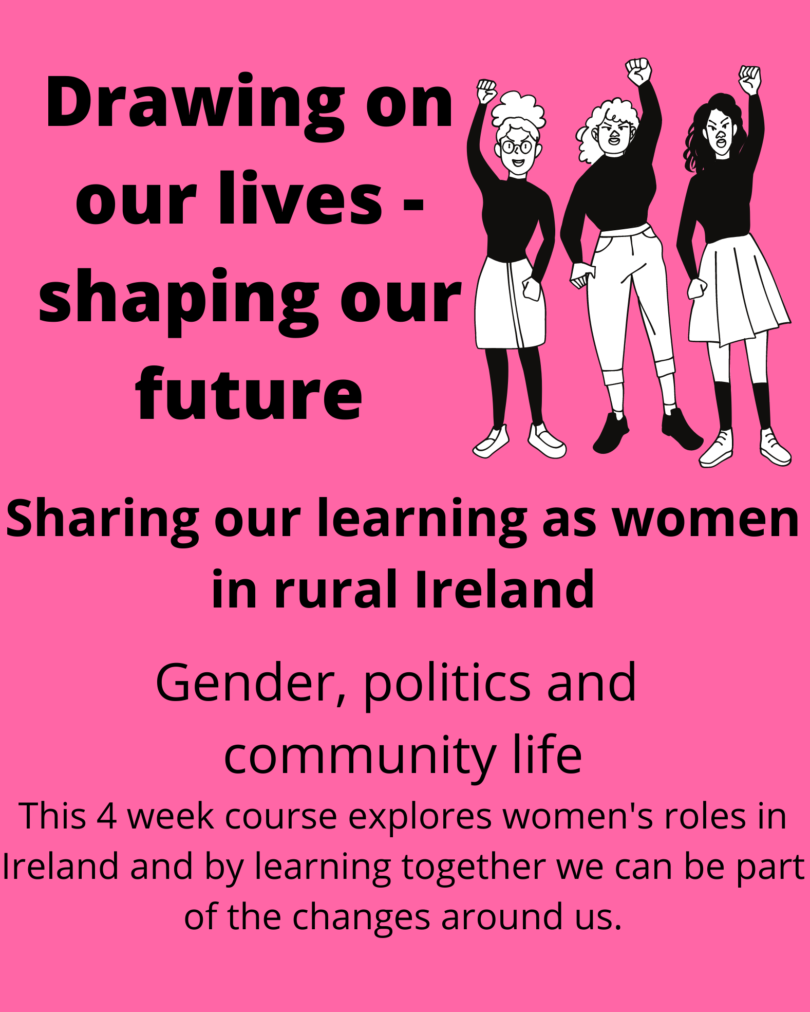

2. Grassroots to Government logo
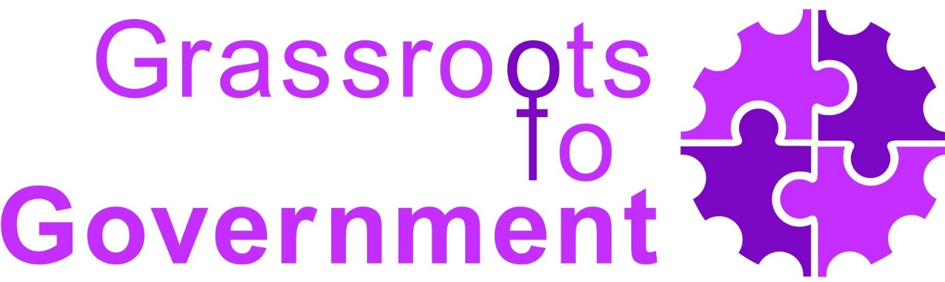

3. Examples of short infographics used in the program
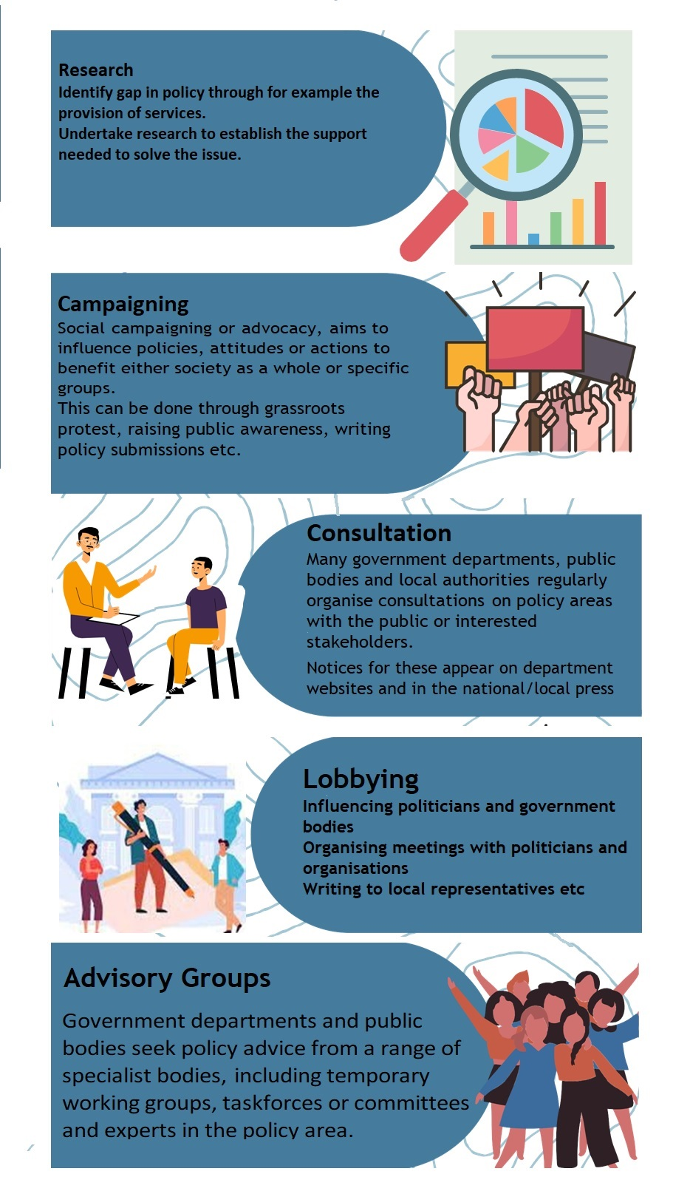

4. Program Promotion Flyer Design
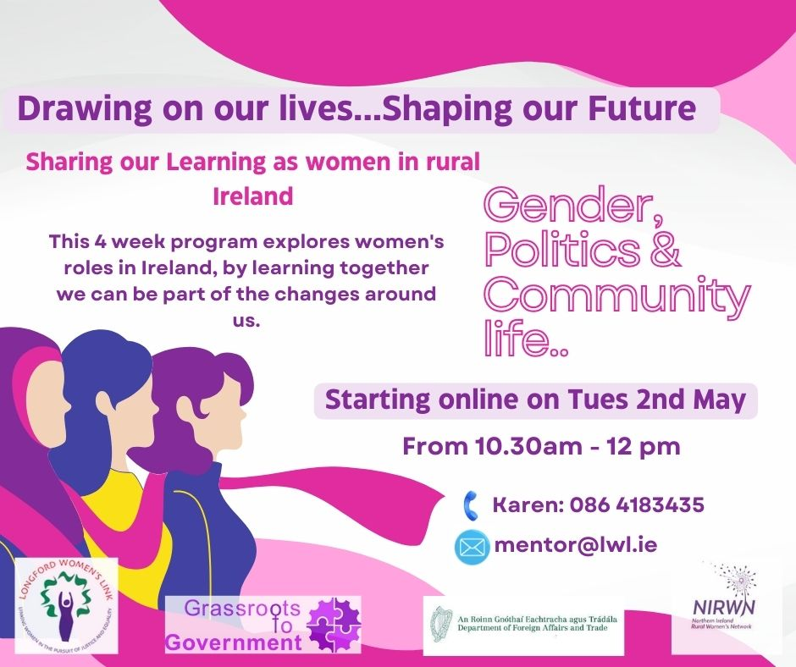

D. Links to important information
- Grassroots to Government - YouTube
- www.grassroottogov.ie
- https://www.lwl.ie/
- https://www.nirwn.org/
- https://crossborder.ie/

