Social Policy

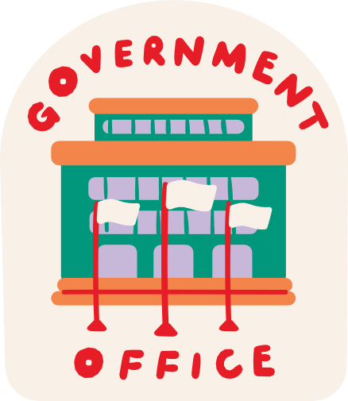
What is Social Policy?
Social policy touches all of our lives. Its fundamental concerns are about human need, social justice, and individual and collective wellbeing.
Addresses issues and needs in society such as education, housing, welfare, health and care, gender equality, and the environment.
Social policy can be influenced by civil society through lobbying and campaigns.

What does Social Policy look like?
Social Policy can take many forms. It can mean promises in political party manifestos or the programme for government.
Social policy becomes the laws and regulations, national strategies, funding plans, government circulars and the budget.
Each government inherits existing policies and can change them or introduce new ones.

Developing Women in the Community

Example of Social

Policy
Key Objective: The programme sought to contribute towards safer communities, that were resilient to paramilitarism, criminality and coercive control.
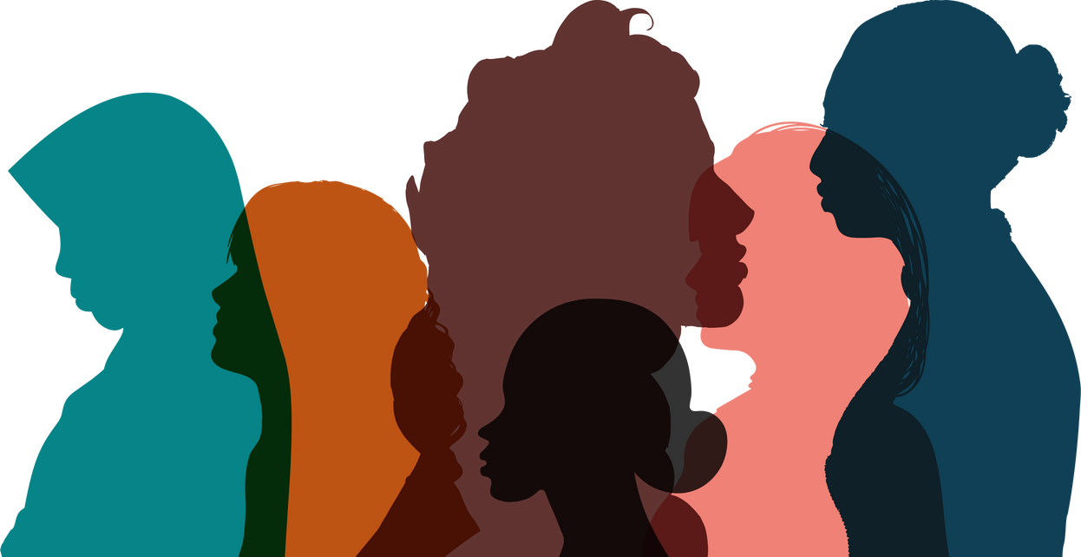
Actions:
local organisations were invited to bid for resources of up to £30,000 to run a local project in response to identified local need.
Modules focused on, roles of women within families and communities, confidence and self-esteem, teamwork and collaboration etc.
Review was undertaken for next phase.
Implementation of Policy
- How policy is actually implemented in practice can be different to the written intention of government or a public body.
- Shortcomings or loopholes between formal policies and how things work in practice are sometimes referred to as implementation gaps.
- Implementation depends on how much effort, emphasis and funding is given to a policy.

