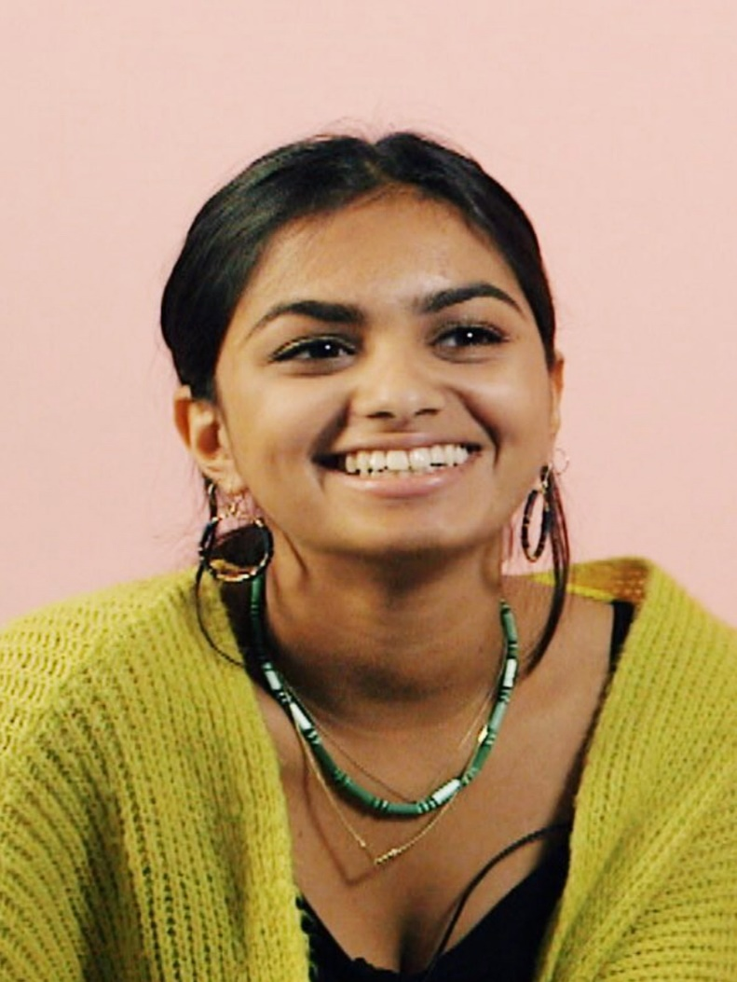
Amika George is the 18-year-old founder of #FreePeriods. Like many of us, Amika was shocked to discover that many young women in the UK cannot afford sanitary items when they're on their period. Not one to sit there and let the issue resolve itself, Amika took action by starting the #FreePeriods campaign. Schoolgirl by day, activist by night.
Gradually picking up momentum since its inception this spring, Amika's #FreePeriods will end the year on a high with a peaceful protest on December 20 calling for prime minister Theresa May to "provide free menstruation products for all girls already on free school meals."
When did you decide to start #FreePeriods?
I started #FreePeriods in April this year after I read an article that totally horrified me. I read how there were girls living in the UK who couldn’t afford to buy menstrual products, and would improvise every month with socks Sellotaped to their knickers and stuffed wth toilet roll stolen from public loos, or would tear up old T-shirts and use those.
I felt sickened that this was happening in a wealthy country like ours, and worse still, that no action had been taken. Girls were missing school because they daren’t go to school without protection - the consequences didn’t bear thinking about. I started a petition to call on the government to provide free menstrual products to girls from low-income families, and decided to spread the word and talk unashamedly, not just about period poverty but about menstruation!
Why does this cause feel so important to you?
It’s so important because as young women, we face a multitude of hurdles in our fight for equality. To think that we bleed because of a bodily function we have no control over and have that as an additional obstacle is so unfair! No girl should be missing school because she can’t afford to have a period. No girl should be faced the indignity and constant stress of knowing she’s bled over her uniform in front of her class because she can only afford one tampon or pad, or worse still, no tampon or pad. These girls lag behind in their education because of sustained gaps in their learning, and never achieve their goals. That’s not fair. The government isn’t taking action and places the responsibility firmly in the lap of the schools who are already so outrageously stretched in their funding, or parents, who often rely on food bank handouts to feed their children. The #FreePeriods campaign is also about breaking down the ridiculously outdated stigma around menstruation - it has to go - we need to embrace our periods and be proud to bleed. We need to celebrate and not hide our periods!

If you could sum up the ethos of the project in five words, what would they be?
Fighting injustice, praising period power!
How do you think being a young woman campaigner impacts the outcomes of your success?
I think that girls can relate to me since I’m a schoolgirl myself and know I will understand the ramifications of missing weeks of school and getting bogged down in mountains of catch-up lessons, so girls are open in telling me how period poverty impacts them. That then just makes me fight harder for them!
The negativity I hear sometimes in fighting for what’s perceived as a "woman’s issue" is inevitable and unsurprising; comments from some men like "I don’t want to hear about periods when I’m eating my breakfast" or comments like "if you want pads, I want razors" are, thankfully, not that common. But in 2017, so many women have achieved remarkable things and it’s an era where women feel empowered and emboldened to not accept the status quo.
What has been the biggest obstacle you’ve faced thus far?
The silence surrounding menstruation means that people don’t always feel comfortable talking about period poverty. I’ve seen grown men gingerly shuffle away when I broach the subject, and I’ve lost count of the number of red faces I’ve seen when I mention the word period. The taboo around periods means that men feel it’s not their problem and this is partly because women are also ill at ease in discussing menstruation between ourselves. We talk in whispers and in apologetic tones to each other, to our friends, to our sisters. Unless we break the stigma and normalise conversation around menstruation, we will never accept that periods make women incredible and our bodies powerful.
You’ve actively used social media - what do you think the significance of these platforms is for activism right now?
Over 83k people have added their name to the #FreePeriods online petition, and that's still rising. Together, we are the collective (and global) army who are unequivocal in demanding change. Social media gives us a really powerful weapon and it’s so easy now to mobilise people into action - I started my campaign on my own one rainy Friday from my bedroom, but not once have I felt like I was in this on my own! Together with the Pink Protest, we are organising the #FreePeriods protest for December 20, and social media has enabled us to spread the word, publicise speakers, and create a platform for people everywhere to know that they are participating and are instrumental in eliciting change.
How does it feel when you see the work you’ve done actually directly impact people in a positive way?
There are wonderful campaigners out there who are also fighting period poverty and for those girls who are suffering from period poverty every month, they know they now have a voice through us. Just talking about the campaign, in whichever platform I can, whether it’s on TV, in newspapers or in schools means we are talking about menstruation, and that’s brilliant. Girls have told me that they feel more comfortable talking to teachers about it because they feel they can be more open about periods. That’s incredibly important in helping us to gauge the magnitude of the problem in schools and understanding what exactly is needed as a solution.

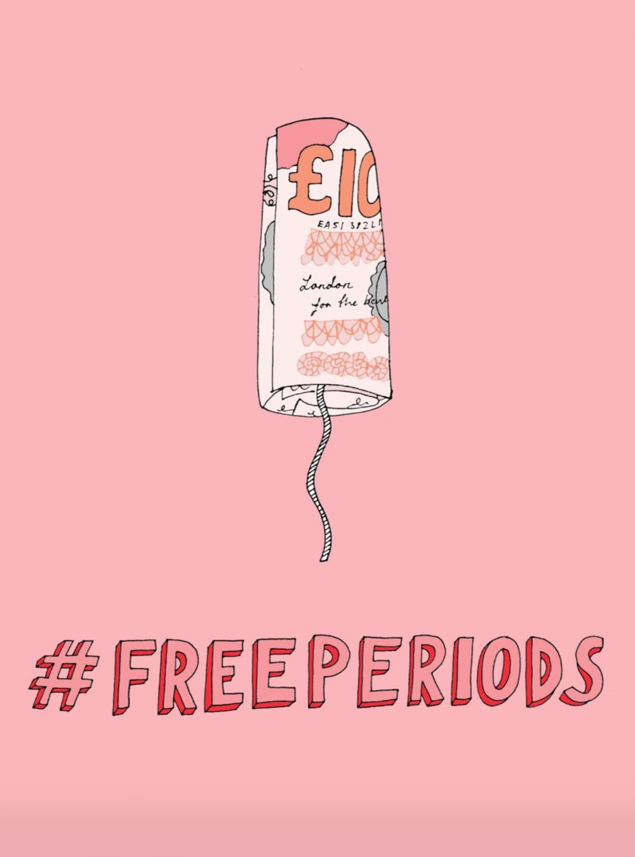
Something that’s encouraged and motivated me is seeing how other young people who’re involved in the #FreePeriods campaign have themselves found personal fulfilment in activism. A teenage girl who dropped out of school because she suffered from anxiety who’s helping with our campaign tells me she’s discovered her voice can make a real difference and feels like she’s contributing to society in a positive way; two Welsh teenage boys who were inspired to start a charity to collect menstrual products for homeless women gave me such a boost in seeing that men are starting to see period poverty as an issue that everyone must solve together!
Who would you love to see support #FreePeriods?
Women who have a global voice, like Meghan Markle, are instrumental in highlighting issues that lie dormant or need attention to get media interest. Meghan’s been a fierce advocate for fighting period poverty and she’s witnessed how period poverty can rob girls of their childhood and their education. But I’d love everyone to support us! We need everyone to write to their local MPs, urging them to raise period poverty in parliament, we need everyone to come to the protest, to write about it, to talk about it, and just make as much noise as possible about needing the government to make change happen. Soon.
Lastly, you’ve 150 words to use as a bit of a Soapbox to say whatever you want about the issue you support - go for it!
The #FreePeriods movement is gathering pace and I urge everyone to be a part of it. Please come to the protest and take a stand against period poverty. We need to make sure girls can be whoever they want to be and education is often the easiest way to achieve that. Without education, girls become trapped in the cycle of poverty for generations. A normal biological process affecting half of the world’s population shouldn’t stop any of us from being the best version of ourselves, should never make us feel ashamed of our bodies and should never inhibit us from having an equal platform in which to excel as boys. Let’s praise the period and tell everyone you meet about how bloody remarkable our bodies are.

